Instructions for Accessing Independent Learning Courses and Downloading Certificate

Step 1  Go to https://neapartnera.learnupon.com/  OR  Use the direct link provided to go directly to enroll in the course  Log in or create an account | 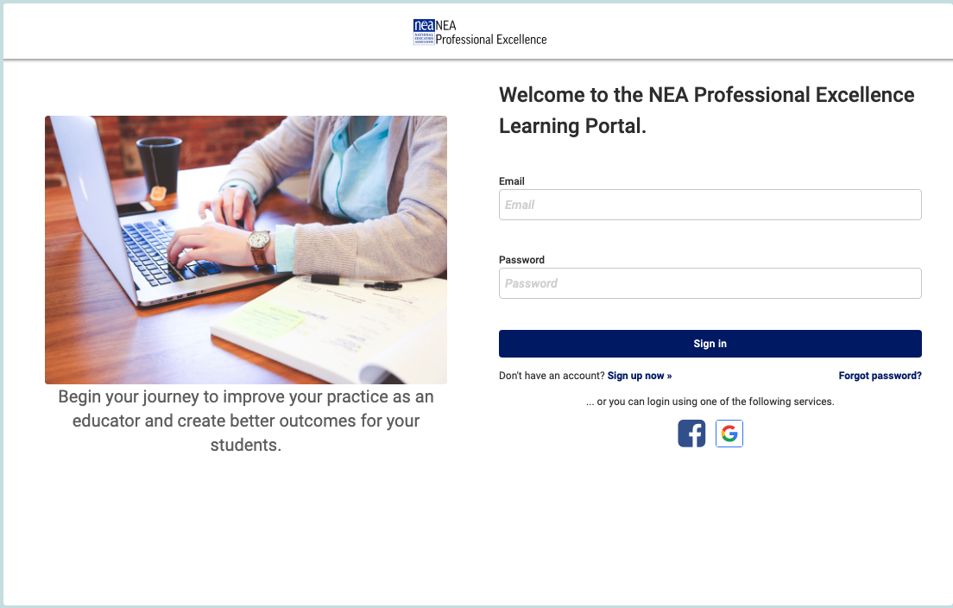
Step 2  Click on the “Dashboard” button (upper left corner)  If you used the direct link skip to step 4 | 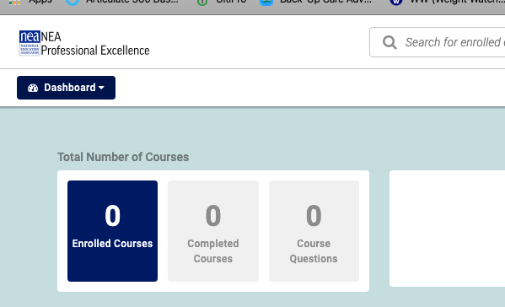
Step 3  Click on “Catalog” | 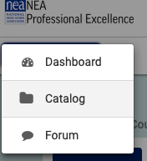
Step 4  Find Course  Click on the “Enroll” button | 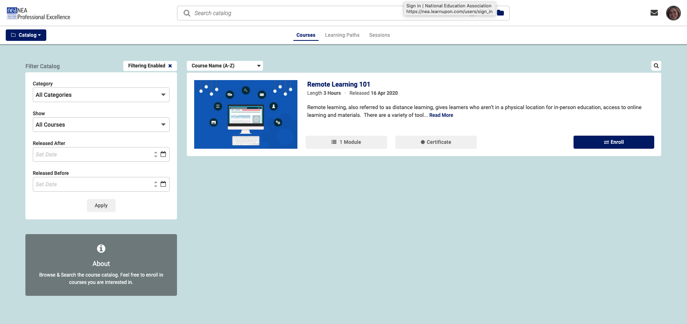
Step 5  Confirm that you wish to enroll | 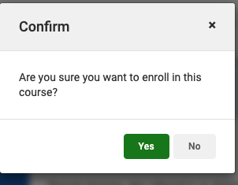
Step 6  Click on the “Start” button | 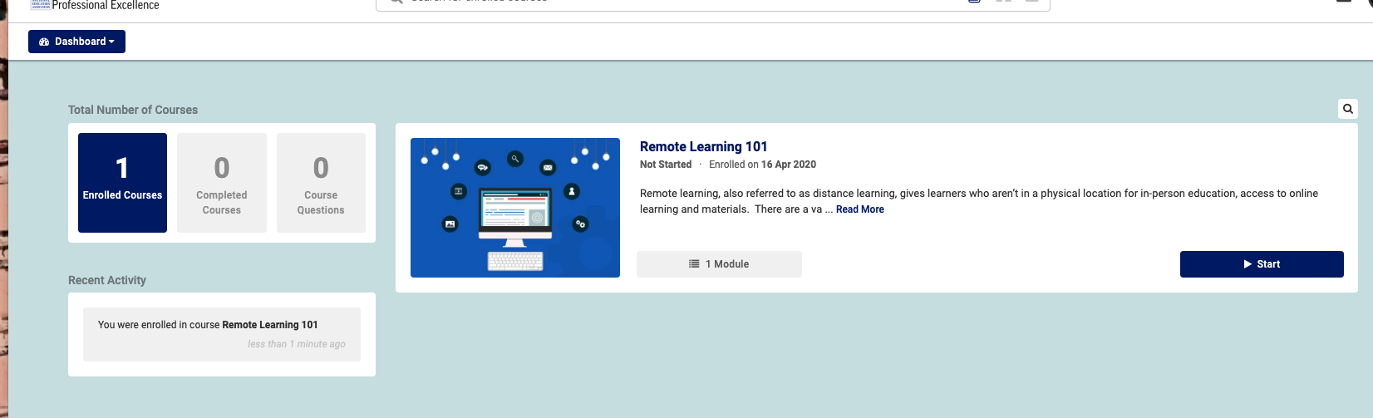
Step 7  Click on the “Start Course” button | 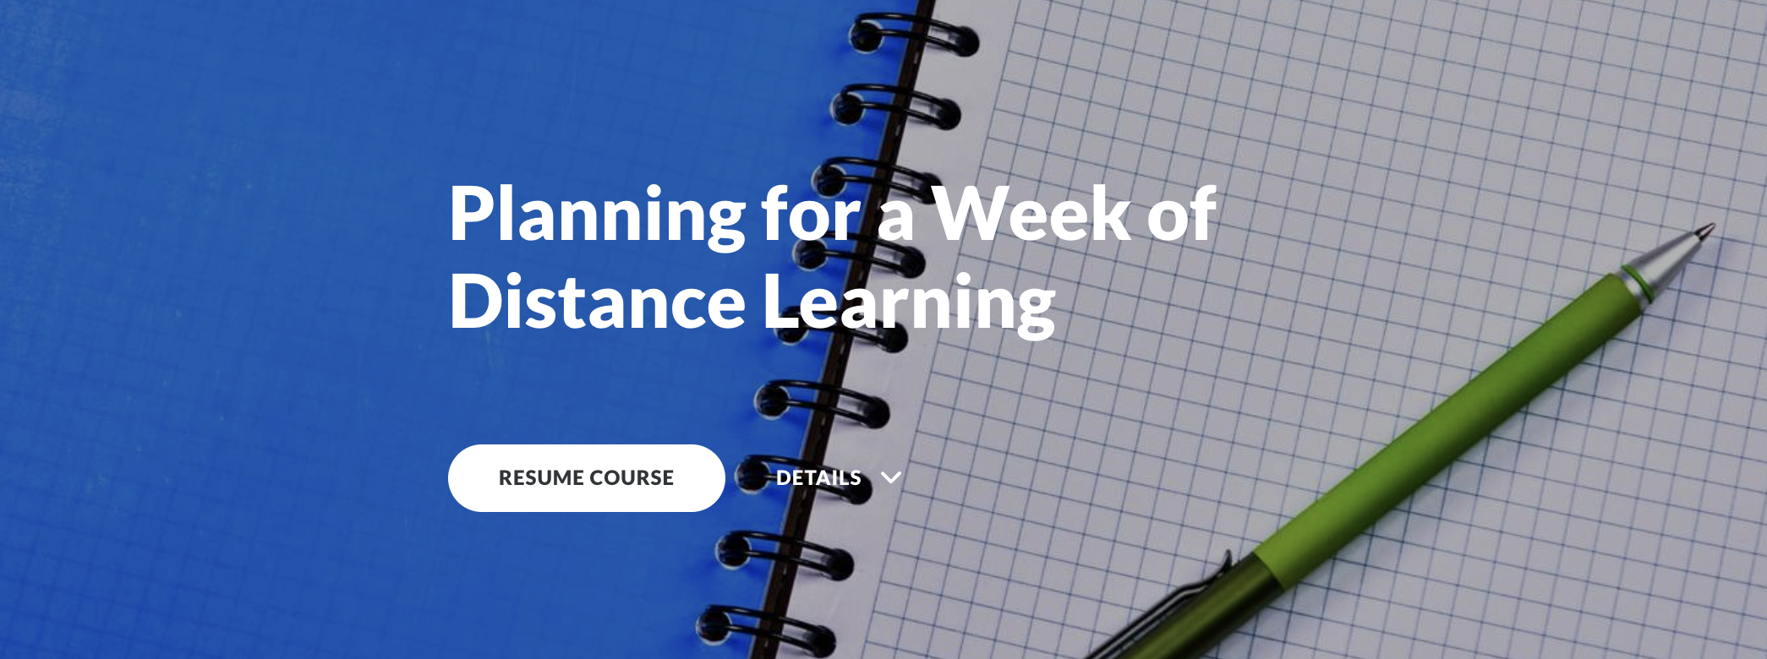
Step 9  Navigate through the course | 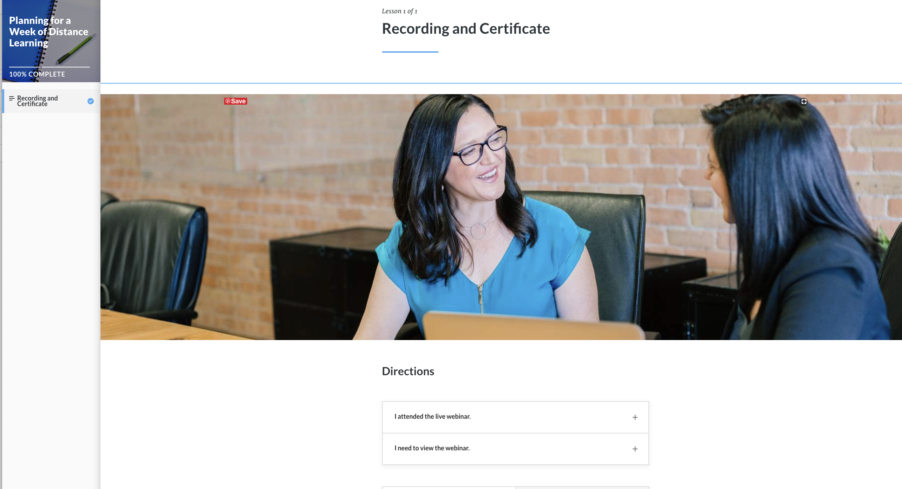
Step 10  Download Certificate | 