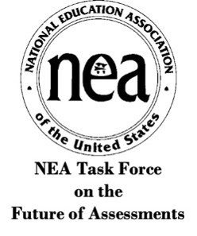

DRAFT PRINCIPLES FOR THE FUTURE OF ASSESSMENTS
Task Force Co-Chairs Princess Moss & Hanna Vaandering

The NEA Task Force on the Future of Assessments presents this draft, which outlines five principles for ensuring that all students have access to an equitable, robust system of asset-based assessments designed by educators in partnership with stakeholders that values the full breadth of their knowledge and skills.

Fulfilling these principles will transform assessments to advance inclusion, equity, and racial and social justice in our schools. By equipping educators and all stakeholders with skills and strategies to implement racially and socially equitable assessments, together we will foster student success.

- Create democratized, community-based, and student-centered processes for assessing student growth, learning and development.
- Prioritize assessment literacy and ensure racially and culturally responsive assessment that meet the needs of all students.
- Assess what is meaningful to student well-being, learning, and growth. Share results with all stakeholders in a way they can understand and use to the benefit of learners.
- Design assessment that inspires learning and decouples student assessment from tracking, promotion/retention, and graduation decisions to end student segregation and inequitable access to a well-rounded curriculum.
- Provide students, educators, and schools with the resources needed to make these principles come alive, with opportunities for students to demonstrate their comprehension, creativity, and skills.

