**NCHE Secretary**

**Elect**

**Marcia Mackey**

As a proud union member, I serve at the national level on the NEA Board of Directors and the NCHE Executive Committee. For NCHE, I served two years as an At-Large Member of the Board, then stepped into the Secretary position in August 2019. For NCHE I was very involved in the revisions to the Constitution & Bylaws that passed in 2019. It would be a privilege and honor to continue to serve as the NCHE Secretary.

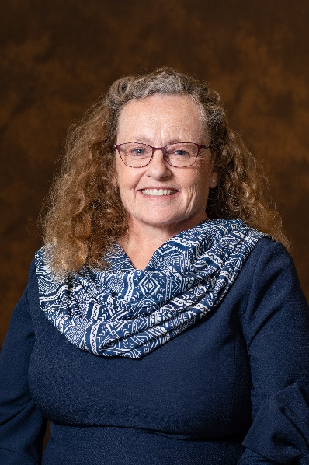

**Leadership**

* 5 yrs. NEA Board of Directors
* 9 yrs. MEA Board of Directors
* 5 yrs. NEA RA – MEA Region 12 Coordinator
* 11 yrs. MAHE Board
  + 4 years as V-P for 4-year institutions
  + 3 years as President
* 6 yrs. NCHE Executive Board
* 24 yrs. CMU FA Board – MEA/NEA Rep, Dept. and College Rep, Crisis Committee
* 4 yrs. NEA & 14 yrs. MEA Resolutions Committees
* MEA Committees – Governance Review, Conference Planning (winter & summer), Social Justice, and LGBTQ+

Greetings! I am a candidate for the NCHE Secretary position because I believe in the importance of service to NCHE, to advance the value of public higher education. Currently I serve as the secretary for MI 12-F Coordinating Council, MI Region 12, and NCHE. I maintain detailed minutes, distribute them promptly, and ensure organization policies are followed. I have been very involved in the review of local bylaws, as I serve on the MEA Governance Review Committee.

I am on the NEA BOD Higher Education Conference Planning Committee and am a voice for NCHE in terms of pushing for separating our conference from the NEA Leadership Summit.

I am willing to commit the time and energy necessary to advance a positive, proactive agenda for the benefit of all NCHE members.

**Work Experience**

* 31 yrs. – CMU
  + Associate Professor
  + Aquatics & Sport Management
* Elementary, middle, and high school – swimming and physical education
* Coaching
* Aquatic facility director

**Related Experience**

MEA Region 12 Secretary

MEA 12-F CC Secretary

NCHE Secretary

Paid for by the Committee to Elect Marcia Mackey

**Elect**